Name: Puna Poudel

Assignment: Module 4.2

Due Date: 6/23/2024

Professor: Chandra

Github url: <https://github.com/punaram14/csd-310.git>

Database connected screenshot:

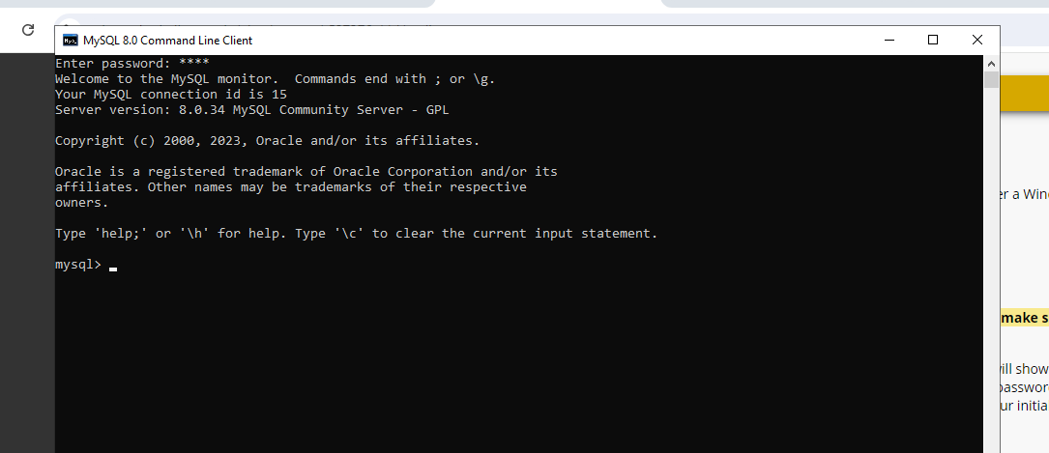

Database created

